a
5.17 Design a one-input, one-output serial 2s complementer. The circuit accepts a string of
bits from the input and genera

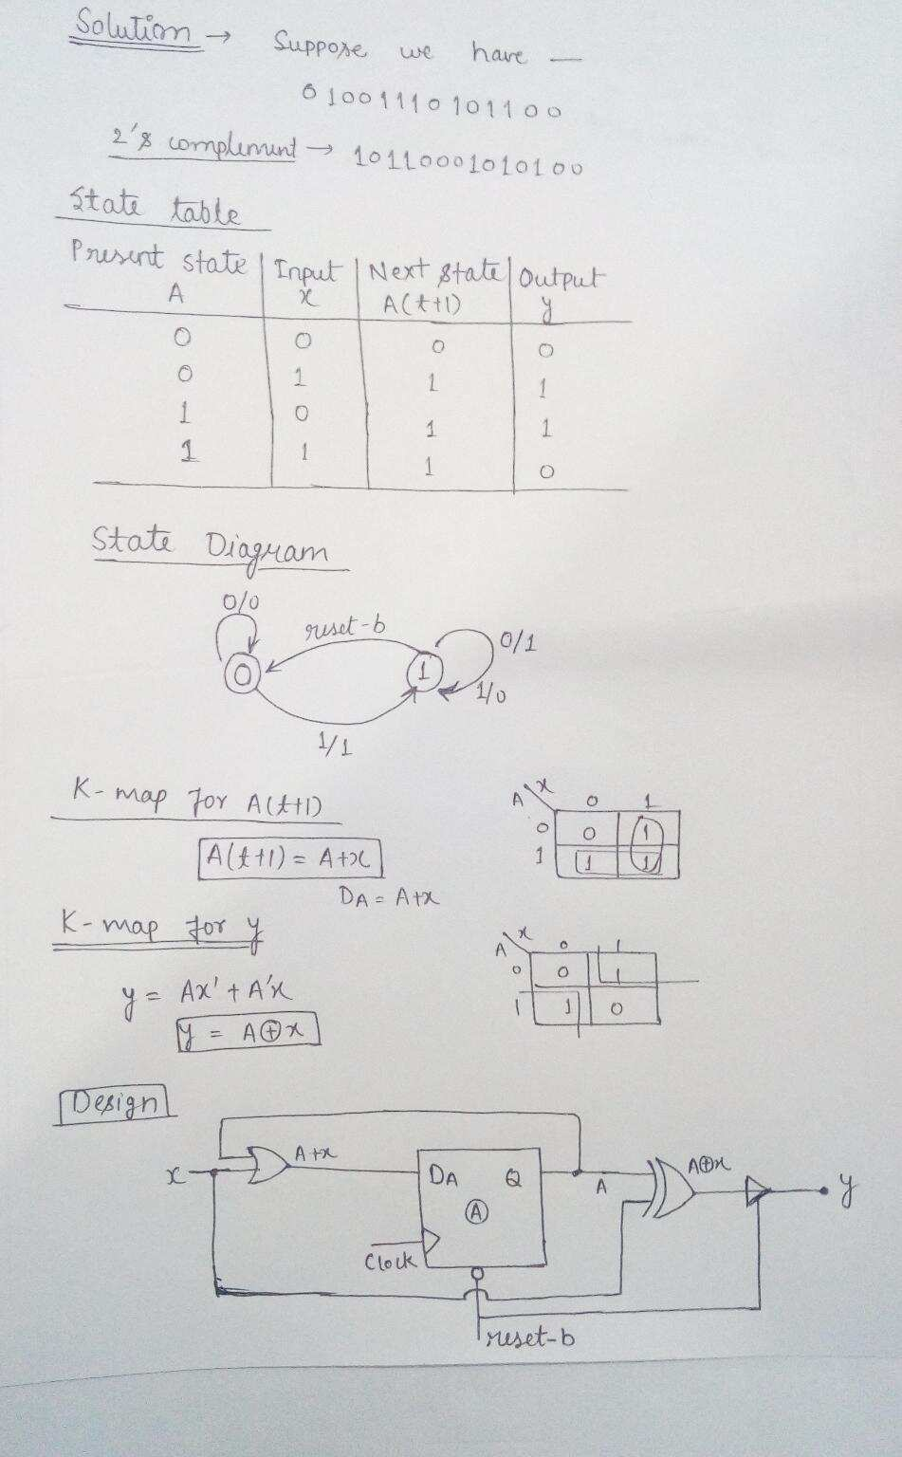

<https://www.youtube.com/watch?v=aHgM51UaFmc>

**Question 2:**

Where z = cin and x,y = A and B (inputs at select lines as shown in diagram)

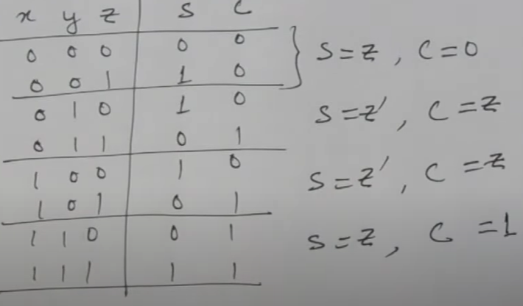

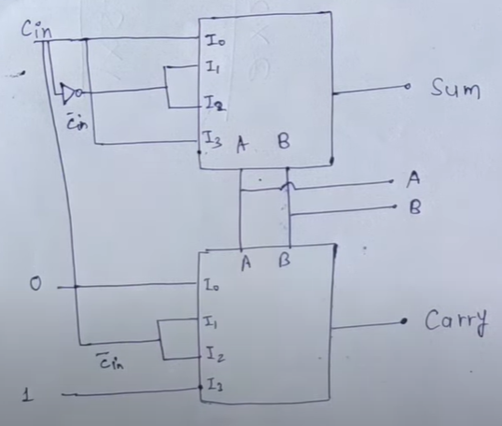

Question 3:

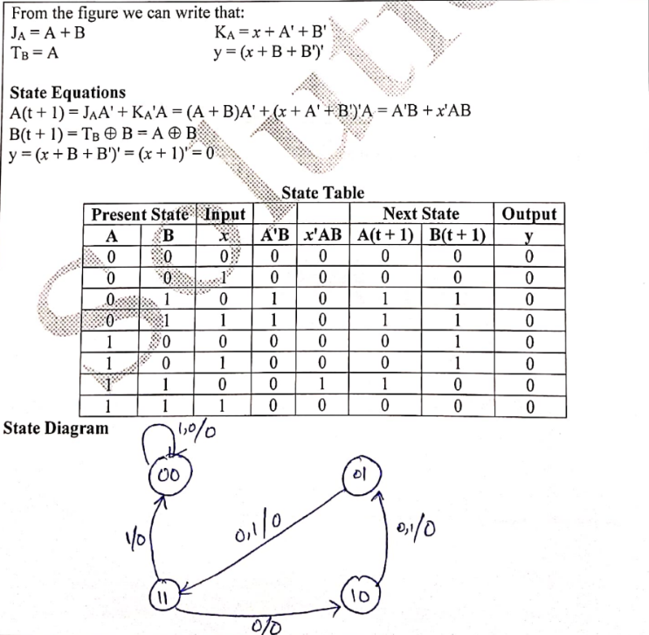

Question 4:

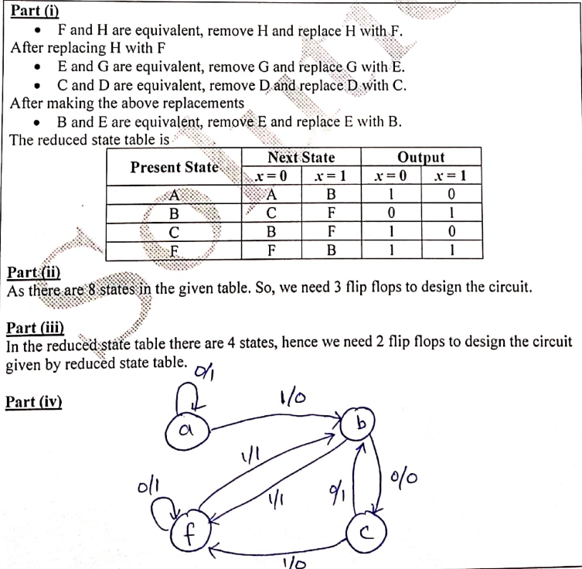

**Question 5:**

\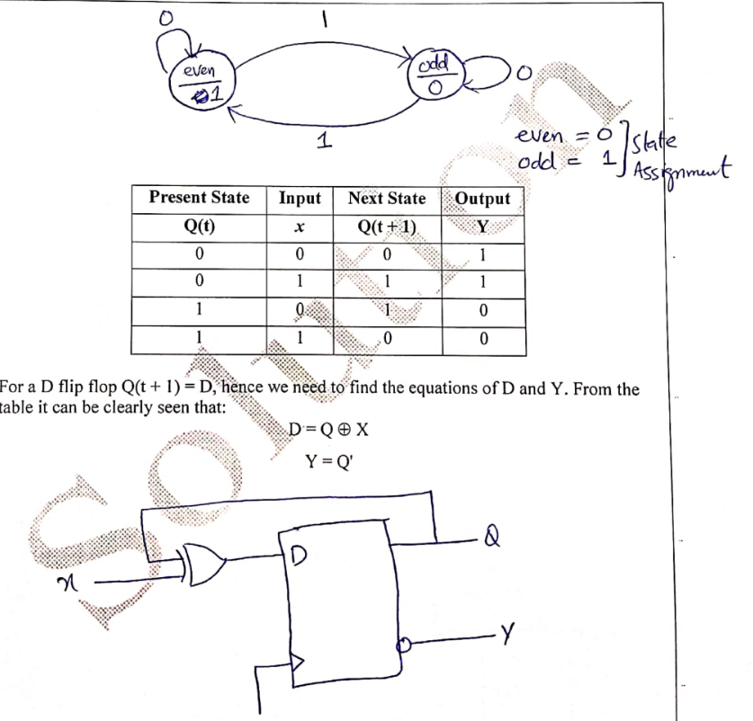

**Question 6:**

**Question 1: Multiplexer (MUX)**

**What is the function of a 4-to-1 multiplexer?** A) Combines four inputs into one output. B) Selects one of four inputs to output. C) Divides one input into four outputs. D) Encodes four inputs into fewer lines.

**Answer: B)** Selects one of four inputs to output.

**Question 2: Decoders**

**What is true about a 2-to-4 line decoder?** A) Activates multiple outputs at a time. B) Has 4 inputs and 2 outputs. C) Has 2 inputs and 4 outputs, one active at a time. D) All outputs are always active.

**Answer: C)** Has 2 inputs and 4 outputs, one active at a time.

**Question 3: Latches**

**What does a D latch do?** A) Divides the clock frequency. B) Stores a bit when enabled. C) Converts serial to parallel data. D) Toggles between states.

**Answer: B)** Stores a bit when enabled.

**Question 4: Sequential Circuits**

**What feature do sequential circuits have?** A) Only arithmetic operations. B) Memory elements. C) No clock signals. D) Faster than combinational circuits.

**Answer: B)** Memory elements.

**Question 5: Decoders and MUX**

**How can decoders and multiplexers be used together?** A) Decoder enables multiplexer signals. B) Multiplexer selects decoders. C) Decoder outputs connect to multiplexer inputs. D) Multiplexer generates decoder selection lines.

**Answer: A)** Decoder enables multiplexer signals.

**BONUS:**

The answer to this riddle lies in the way the apples are taken from the basket. Here’s how it could work:

1. You take an apple, leaving **four** in the basket.
2. Your friend takes an apple, leaving **three** in the basket.
3. Their friend takes the last apple, but they take it **along with the basket**.

So, the friend took both an apple and the basket, which still had one apple in it. Therefore, one apple remains in the basket. It’s a clever play on words!